Assessment – 2
DSA05 – Query Processing for Data Science
CO1 - Assessment Tool 2 - Application Based Questions
S. Sharon Surya
192324246

- School Library Usage Analysis (10 Marks)
A school maintains book information in JSON format and borrowing records in CSV format. Write a Python program to combine the datasets, determine the most frequently borrowed books, and generate a library usage report.

- The program imports the Pandas library to perform data processing and analysis.
- It reads the borrowing records from a CSV file and the book details from a JSON file.
- Both datasets are combined using the Book_ID column with the merge() function so that each borrowing record includes the corresponding book information.
- The program groups the data by Book_Title and counts how many times each book has been borrowed using the groupby() and size() functions.
- Finally, the books are sorted in descending order based on the number of borrowings, and a Library Usage Report showing the most frequently borrowed books is displayed.

Program
import pandas as pd
# Read CSV and JSON files
borrow = pd.read_csv("C:\\Users\\svkss\\Documents\\Query Files\\PythonProject1\\2nd asses\\borrowing_records.csv")
books = pd.read_json("C:\\Users\\svkss\\Documents\\Query Files\\PythonProject1\\2nd asses\\books.json")
# Merge both datasets
library = pd.merge(borrow, books, on="Book_ID")
# Count the number of times each book was borrowed
report = library.groupby("Book_Title").size().reset_index(name="Times_Borrowed")
# Sort by highest borrowed books
report = report.sort_values(by="Times_Borrowed", ascending=False)
print("LIBRARY USAGE REPORT")
print(report)

Output;
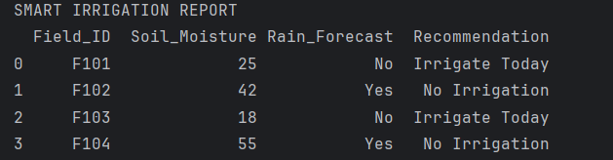
SMART IRRIGATION REPORT
Field_ID Soil_Moisture Rain_Forecast Recommendation
0 F101 25 No Irrigate Today
1 F102 42 Yes No Irrigation
2 F103 18 No Irrigate Today
3 F104 55 Yes No Irrigation

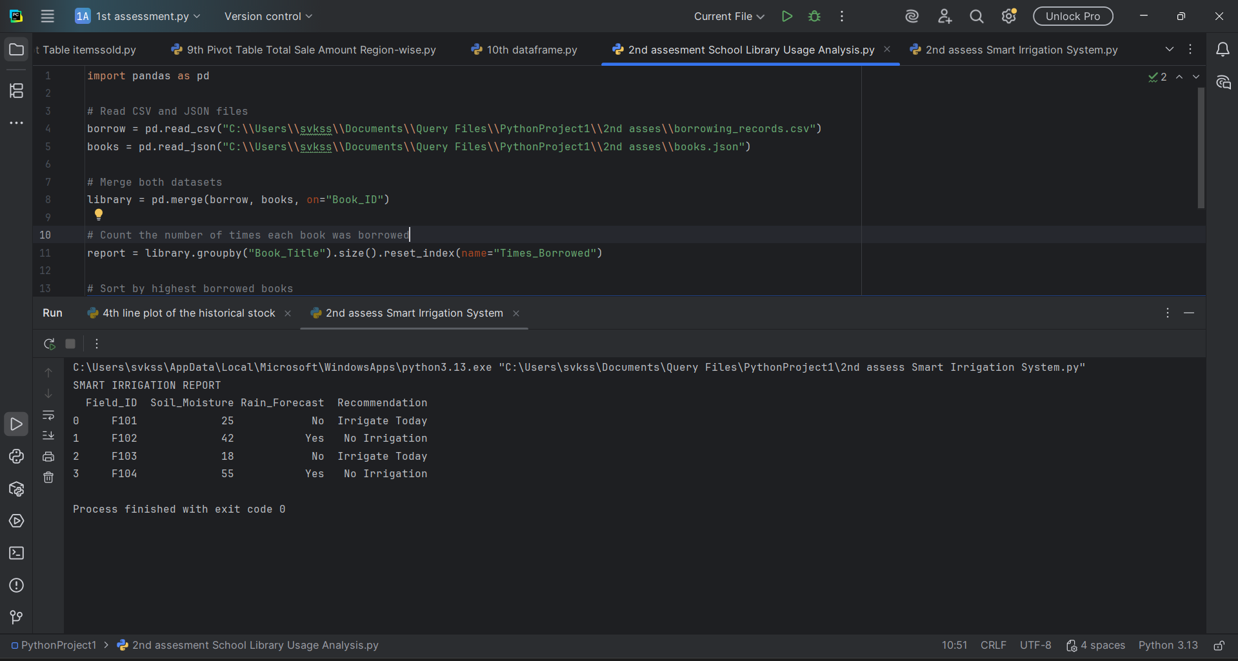

- Smart Irrigation System (10 Marks)
An agricultural research center stores soil moisture readings in CSV format and weather forecasts in JSON format. Write a Python program to integrate the datasets and recommend irrigation schedules for different fields. these are my two application based questions give the python code for this subject query processing

- The program imports the Pandas library to process and analyze the data.
- It reads the soil moisture data from a CSV file and the weather forecast from a JSON file.
- Both datasets are combined using the Field_ID column with the merge() function to create a single dataset for each field.
- A user-defined function checks the soil moisture level and rain forecast to decide whether irrigation is needed.
- The program adds the irrigation recommendation as a new column and displays a Smart Irrigation Report for all fields.

Program:
import pandas as pd
# Read CSV and JSON files
soil = pd.read_csv("C:\\Users\\svkss\\Documents\\Query Files\\PythonProject1\\2nd asses\\soil_moisture.csv")
weather = pd.read_json("C:\\Users\\svkss\\Documents\\Query Files\\PythonProject1\\2nd asses\\weather.json")
# Merge datasets
data = pd.merge(soil, weather, on="Field_ID")
# Function to recommend irrigation
def irrigation(row):
if row["Soil_Moisture"] < 30 and row["Rain_Forecast"] == "No":
return "Irrigate Today"
elif row["Rain_Forecast"] == "Yes":
return "No Irrigation"
else:
return "Monitor Field"
# Apply recommendation
data["Recommendation"] = data.apply(irrigation, axis=1)
print("SMART IRRIGATION REPORT")
print(data)

Output:
SMART IRRIGATION REPORT
Field_ID Soil_Moisture Rain_Forecast Recommendation
0 F101 25 No Irrigate Today
1 F102 42 Yes No Irrigation
2 F103 18 No Irrigate Today
3 F104 55 Yes No Irrigation
